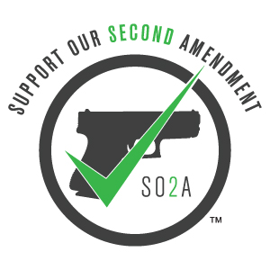

SO2A CWP Class Checklist

The items on this list will be needed upon arrival to the class

- Printed and completed SLED CWP Application (link provided). Please do not sign until arriving to class

- South Carolina Driver’s License with correct address

- Check, cash, or online payment of $100 for class

- Firearm of choice

  - Firearm must be unloaded

    - For semi auto pistols: upon arrival, slide must be pulled back to reveal empty chamber and magazine well (a neon zip tie will be provided to insert into the barrel and out through the chamber to serve as a chamber flag to indicate to the class that the firearm is unloaded)

    - For revolvers: the cylinder must be opened to reveal that it is empty (a neon zip tie will be provided to insert into the barrel to serve as a chamber flag to indicate to the class that the firearm is unloaded)

  - Ammunition must remain in vehicle or a locked box provided by the instructors until range portion of class

  - If you do not have a firearm then one will be provided for you

- A minimum of 50 rounds for your firearm of choice

  - If you are using a firearm provided to you, then a $30 fee will be required for ammunition

